**Bahria University, Lahore Campus**

Department of Computer Science

**Assignment 04**

**(Spring 2023)**

|  |  |  |
| --- | --- | --- |
| Course: | **Data Structures and Algorithm** | Date: 13-06-2023__ |
| Course Code: | CSC-221 | Max Marks: **20** |
| Faculty’s Name: | Ms. Zupash Awais | **Deadline: 13th June 2023** |

Name: AFFAN AHMAD ___ Enroll No: 03-134221-003___ Section: _BS(cs )___

Instructions:

1. Understanding each question is a part of the assignment.
2. This is a Handwritten Assignment.
3. Solve the assignment with full honesty. Leave the question that is not clear to you or you are not able to solve, we will discuss it in the class for better understanding.
4. Try to think of a solution of your own. If you will keep on searching for solutions on Google, it will not make your problem-solving ability strong. This assignment is to sharpen your mind a bit or make you able to solve/think of a solution for any problem.
5. Copied assignments (from each other) will be awarded ZERO.
6. *The assignment is also to be submitted in the soft form on LMS till the deadline mentioned above.*
7. No need to take a colored print or bring the assignment in files. Submit it as a normal black and white stapled paper

***\*\*Provide the solution in the box for each question\*\****

**Question 1 Marks: 10**

For the below given graph perform treversals. Show all Steps. Make proper Queue and Stack.

1. BFS (breadth first search)
2. DFS (depth first search)

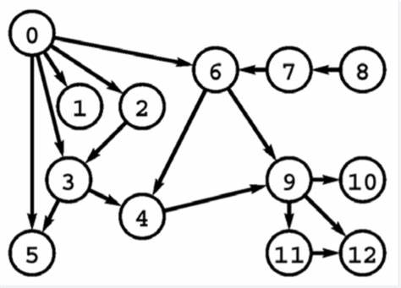

Starting point is **0**.

|  |
| --- |
|  |

**Question 2 Marks: 10**

Draw Heap Tree for the given elements. Perform insertion of MAX and MIN Heap Tree. Show all steps.



|  |
| --- |
| **Max heap tree**  **14**  **/ \**  **13 12**  **/ \ / \**  **9 11 10 8**  **/ \ /**  **2 6 4**  **\**  **7**  **/**  **5**  **Min heap tree**  **2**  **/ \**  **6 4**  **/ \ / \**  **8 10 7 5**  **/ \ / \**  **13 9 11 14**  **/**  **12** |